DATASET ACTIVATE DataSet1.

GRAPH

/SCATTERPLOT(MATRIX)=Intelligence Extroversion SalesPerWeek

/MISSING=LISTWISE.

**Graph**

[DataSet1] C:\Users\BuroK\Google Drive\MacEwan\Teaching\Stat161\Notes_Moore\Data\Sales.sav

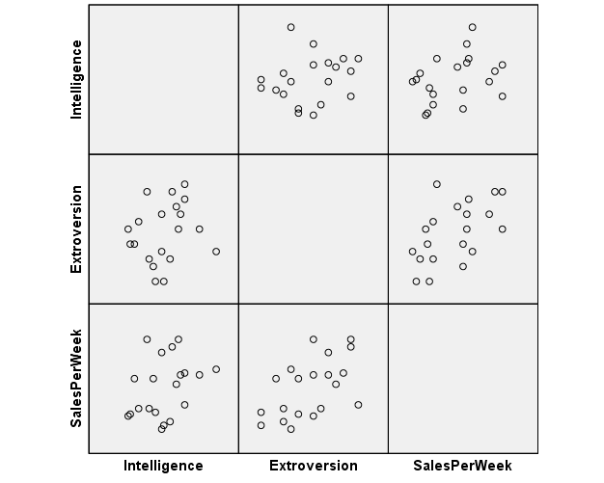

GRAPH

/SCATTERPLOT(MATRIX)=Intelligence Extroversion SalesPerWeek

/MISSING=LISTWISE.

REGRESSION

/MISSING LISTWISE

/STATISTICS COEFF OUTS R ANOVA

/CRITERIA=PIN(.05) POUT(.10)

/NOORIGIN

/DEPENDENT SalesPerWeek

/METHOD=ENTER Intelligence Extroversion.

**Regression**

|  |  |  |  |
| --- | --- | --- | --- |
| **Variables Entered/Removeda** | | | |
| Model | Variables Entered | Variables Removed | Method |
| 1 | Extroversion, Intelligenceb | . | Enter |

|  |
| --- |
| a. Dependent Variable: SalesPerWeek |
| b. All requested variables entered. |

|  |  |  |  |  |
| --- | --- | --- | --- | --- |
| **Model Summary** | | | | |
| Model | R | R Square | Adjusted R Square | Std. Error of the Estimate |
| 1 | .594a | .353 | .276 | 332.069 |

|  |
| --- |
| a. Predictors: (Constant), Extroversion, Intelligence |

|  |  |  |  |  |  |  |
| --- | --- | --- | --- | --- | --- | --- |
| **ANOVAa** | | | | | | |
| Model | | Sum of Squares | df | Mean Square | F | Sig. |
| 1 | Regression | 1021166.374 | 2 | 510583.187 | 4.630 | .025b |
| Residual | 1874583.626 | 17 | 110269.625 |  |  |
| Total | 2895750.000 | 19 |  |  |  |

|  |
| --- |
| a. Dependent Variable: SalesPerWeek |
| b. Predictors: (Constant), Extroversion, Intelligence |

|  |  |  |  |  |  |  |
| --- | --- | --- | --- | --- | --- | --- |
| **Coefficientsa** | | | | | | |
| Model | | Unstandardized Coefficients | | Standardized Coefficients | t | Sig. |
| B | Std. Error | Beta |
| 1 | (Constant) | 993.925 | 788.099 |  | 1.261 | .224 |
| Intelligence | 8.220 | 7.013 | .233 | 1.172 | .257 |
| Extroversion | 49.709 | 19.634 | .503 | 2.532 | .021 |

|  |
| --- |
| a. Dependent Variable: SalesPerWeek |